

**e-Yantra Robotics Competition - 2018**

**Pollinator Bee**

**<Team ID>**

|  |  |
| --- | --- |
| **Team leader name** |  |
| **College** |  |
| **Email** |  |
| **Date** |  |

**Q1. Figure 1 is a graph of a PID Controller. (7.5)**

1. **What do the red line and the green line at 0 signify in the graph?**
2. **What effects do the Kp, Ki and Kd values have on the wave shown in the graph?**

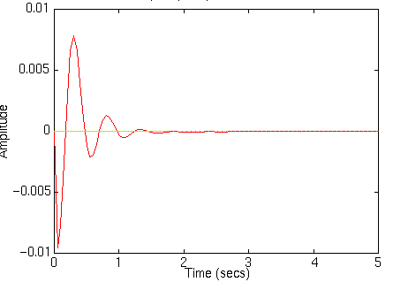

**Figure 1: Graph of a PID Controller**

**Figure 2 is a graph of a PID Controller. Notice how the red line sets itself immediately to the desired set point. For a PID controller with a response as shown in Figure 1, what changes should be made to the Kp, Ki and Kd values in order to achieve the graph in Figure 2? Explain your answer in detail. (7.5)**

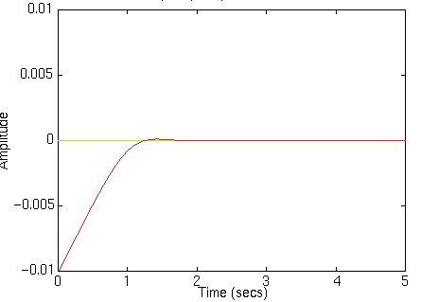

**Figure 2: Graph of a PID Controller**

**Answer: ____________________**

<

State your answer in detail.

Word-limit: 300 words.

>

**Q2. Given a static set point in a 3D space defined by (x,y,z) coordinates, answer the following questions: (i) how would you move the drone from its current position to this set point and (ii) how would you ensure that the drone is on the set point and it is ready to go to the next way point?**

**Explain the pseudocode you would implement in detail. (15)**

**Answer: ____________________**

<

State your answer in detail.

Word-limit: 300 words.

>

**Q3. In order to achieve the task in Problem Statement 1.1, did your team implement a cascaded PID loop or a parallel PID loop for maintaining the roll, pitch and yaw of the drone? Explain the reason of your choice with advantages and disadvantages over the other option. Use a block diagram to explain your answer in detail. (20)**

**Answer: ____________________**

<

State your answer in detail.

Word-limit: 500 words.

>